Elizabeth Anne Milligan Country School Teacher
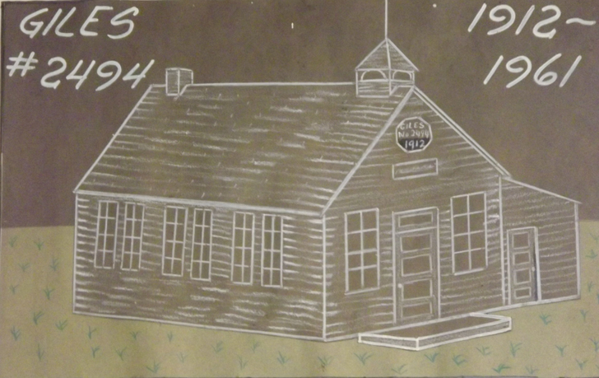
Sixty years ago Elizabeth Anne Milligan, age eighteen and a half, was hired to teach for two months at Giles School, about twenty miles from Wainwright, Alberta. She had completed one year of education at the University of Alberta in Edmonton, and she hadn’t decided if she would go back for a second year. During that time she wrote twice a week to her family at Bon Accord, Alberta; her parents, her four brothers and her eight-year old sister. She wrote mostly to her mother who saved the letters. They were returned to Elizabeth a couple of years before her death in 2009. For me, her sister, they open a window into my memories of her and the years when she was the person I held dearest in my life.
Through the 8,000 words of Elizabeth’s letters, we can begin to understand on a broader scale of what it was like in those days for a young teacher, the community, and society.
It was 1956; Elvis Presley had released his first hit, “Heartbreak Hotel’; rock and roll was sweeping the music scene; Louis St. Laurent was Prime Minister of Canada; and Giles School was looking for its third teacher of the year. The first one had to leave because she was pregnant (a factor in 1956) and the second one was not qualified. The school was typical of its times; built in 1912 and named after Giles James, one of the first settlers. It was located at SW 27-48-4-W4. Translated, that means the southwest quarter of section 27, township 48, range 4, west of the 4th meridian (Baergan, p. 223). The Dominion Lands Act of 1872 established Sections 11 and 29 as school lands. In 1914 Giles school had been moved a section over in order to be closer to the centre of the district.
Initially it was all a “grand adventure” to Elizabeth. She was so ready to be out on her own and in charge. She quickly arranged with the secretary of the School Board to move the piano over to the school from the old community hall and asked her mother to send a book of songs with chording accompaniments and some sheet music to amuse herself with. She made up pet names for students and suitors alike; she commented on everything she saw and heard.
Elizabeth, as a conscientious teacher, was horrified at the lack of knowledge of the students in grades 1, 3, 4, 5 and 9 (about 15 in total) and surprised to find that they were all from Ukrainian families. At first the students seemed unfriendly; “I must have put the fear of the Lord in them all…there isn’t one who has said more than 2 consecutive words to me all week”. She wrote that she had never seen kids like this, especially with her. Shortly thereafter they fell in love with her, and started to bring her crocuses and pussy willows.
As soon as the kids got to like her, they started arriving earlier; “I’ll have to be up at six in order to beat them there”. Six of the kids rode horses to school and the rest walked. They played ball until school started at nine and she had lots of time to write the day’s work on the blackboard. The kids’ greatest fault was that they were careless in their work. “Gee, it makes me mad”, she wrote to her mother.
A school routine quickly developed; the students loved arithmetic, and she taught the grade ones to subtract in the tens (22-10, 37-14), and argued with the grade nines who insisted that 5m² – 3m² was 2 (their previous teacher had said so). She rose to the challenges of teaching five different grades at one time. She taught phonics to grades 1 to 5 all together – and carefully observed that the grade nines were picking up on the teaching technique as well. Departmental exams for the nines loomed at the end of June – she rated their chances of succeeding as very low. The previous teachers had mostly been marking time, she thought.
She used her gardening skills in a one-day cleaning blitz, working with the students to rake the schoolyard, dig up the flower beds, transplant lilac suckers and pick up every orange peel, piece of glass and stick in the yard. Then the students were enthralled when “Teacher” took an hour off from cleanup to play ball with them – “they got very disgusted because they couldn’t put me out”. Her team consisting of the grade ones and threes beat the other team of grades four, five and nine. A little boy named Wayne laughed so hard that he got sick and had to be sent home with his uncle who was going by in the truck.
The inspector arrived the second week. “At first I was really scared but I got over it”, she wrote. The grade nines were in the middle of a grammar exercise and the inspector took over because it looked like she wasn’t getting along too well. “Then the fun began…he gave up in desperation when he was told that the word “school” was a preposition and the difference between a phrase and a clause was that a clause had more words”. She showed him the library (there was none) and asked for curriculum guides in science and social studies as well as some play equipment and grade three readers. The inspector said he should not have sent a brand new teacher to Giles and left “like a dog with his tail between his legs”. “I found it quite amusing”, she wrote. Somehow the community thought she had two years’ experience as well as having graduated from high school two years previously. She didn’t bother to correct them.
Elizabeth boarded with an older couple, Jim and Clara Waddell, who were one of two Irish families in the district. Three “horribly old” bachelors were waiting at Waddells’ upon her arrival and two more were rumoured to be waiting in the wings. She wrote to her father, “DAD I NEED A PROTECTOR”. Still, Jim and Clara watched over her carefully. Jim offered her a shotgun to fend off the bachelors and Clara said, “Tell your mother that I’ll sleep in your room to take care of you if you get sick”. They, like everyone else, thought she was delicate and from the city. That was true – she had lived in the city since a serious car accident two years previously – but it was also false. She was a farmer’s daughter who had had a large hand in raising her younger siblings on the family farm. It was entirely within her world view to notice that the men had started working on the land a week or two earlier than normal. She surprised her boarding family with her enthusiasm for getting out in the coulees and cow pastures and visiting the beautiful Battle River valley. An evening expedition to rescue a cow drowning in the quicksand down by the spring turned into a birds’ egg hunting expedition. “All we found was a magpie’s nest with 4 eggs in it so Howard and Doris and I had an egg fight. I took one egg from the nest and called to Howard – here, catch!! And he put out his hand right in front of his face. Was he ever a mess. I had the advantage of being up the tree luckily”.
She did not completely fit the prescribed mold of a rural teacher; when neighbours walked on her washing her hair in the sink, she nearly died and so did the company , “The only thing was they nearly died laughing”. She was in bare feet , shorts and a little top. The visitor said, “ ‘Well, I didn’t think I’d ever see a schoolteacher in that condition’”. I told them ‘After all, we’re only human. My hair gets dirty and when it gets too warm I naturally take off a few clothes’ ”.
Clara found a young bachelor for Elizabeth – someone who owned his own two quarters of land, drove his own truck and worked out on the oil rigs all winter. The courtship was quick and decisive. On Saturday morning of her first week, the bachelor and his sister turned up at Clara’s at 8: 30 AM and waited til Elizabeth got up at 11:15. Actually she had been up for an hour, “watching the proceedings through the keyhole”. When she decided to appear, Clara cleared the kitchen so the bachelor could ask Elizabeth if she wanted a ride to town (Wainwright). “I’ve never in my life seen a guy so embarrassed”, she wrote. The ride turned into a date for the drive-in – maybe it could have turned into something else if the bachelor hadn’t turned up wearing cowboy boots, green pants, plaid shirt and a wine blazer “four sizes too small”. Plus he didn’t say more than five words to her the whole time, or so she claimed. The next time the cowboy dropped in, Elizabeth hid in the school. When he made the mistake of coming to the school a few days later, she “lit into him” and “just dared him to ever set foot on the school ground again”. He didn’t, and the other bachelors whose trucks had conveniently got stuck at Waddells’ driveway or who had needed to borrow something from Jim vanished back to their shacks.
She missed her family; “Today is Mother’s Day”, she wrote, “I sure wish I was home. What I wouldn’t give for a good gab”. She asked her younger brothers to write to her and her sister to draw a picture.
The first inkling that a rural life was not for her began with an early letter, “I feel like I am a million miles from earth”. She was staying with one of the only families in the district who didn’t have electricity. (This was supposedly because Clara thought the electricity would seep out into the house). When she stayed up past midnight to prepare lessons, she must have been using lamplight. By June 4 Elizabeth was writing her address on the top of her letters as “somewhere in thebackwoods”. By June 15 she had started to count the days. By June 30, Elizabeth Anne Milligan’s sojourn as a country teacher was over.

